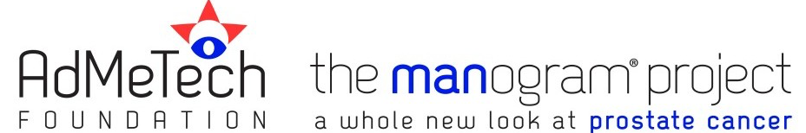
Prostate Cancer Awareness Day at the Atlantic Union College

SPONSOR REGISTRATION FORM
Please fax this form to AdMeTech Foundation at (617) 507-2439 or email contact@admetechfoundation.org

NAME OF COMPANY (IF APPLICABLE): _____________________________________________
REPRESENTATIVE/INDIVIDUAL _____________________________________________
Full Name: ________________________________________
Title: ________________________________________
E-mail: ________________________________________
Phone number: ________________________________________
Address: ________________________________________
LEVEL OF SPONSORSHIP (See attached details): PLEASE REPLACE WITH THE AUC BROCHURE INFORMATION RE: CORRECT NAME AND $ OF SPONSORSHIP LEVELS
Silver: $5,000 ___ Bronze: $2,500 ___ Copper: $1,500 ___ Pewter: $500 ___ Exhibitor: $2,500 ___
METHOD OF PAYMENT
I. Check ____
Please mail check payable to AdMeTech Foundation to:
AdMeTech Foundation, One Boston Place, Suite 2600, Boston, MA 02108
II. Credit Card ____
Name on credit card: ________________ Amount to be charged: $__________
Credit Card Number: ______________________________ Exp. Date: __________
Approval of use via this signature: ___________________________________
III. Wire Transfer or ACH____
Formal Name: Corporation for Advancement of Medical Technologies (DBA AdMeTech Foundation)

Routing Number (Bank of America:

For Wire___ 026009593
For ACH___ 052001633)

Bank account____ 003916329827

